**GitHub profile setup and VS Code user installation for local machine:**

Git hub profile setup:

Use the video links below to setup a Git Hub Profile:

1. Profile Setup: <https://www.youtube.com/watch?v=ZhHDfZ-l7ZU>
2. Creating a repository by forking an existing repo from a different user: <https://www.youtube.com/watch?v=ZB9VgHFqqXU> . Use this tutorial to fork the REEU repo from Professor Krogmeier’s GitHub profile [here](https://github.com/jvkrogmeier/REEU-22-0718).
3. For the setup in the class:
4. Navigate to your admin folder *username*(\\pasture. ecn .purdue.edu). Create a new folder and name it REEU_” yourname”. Insert your name instead of “yourname”.
5. Inside this folder create another folder and call it REEUPython
6. Log into GitHub and download the zip file of Professor Krogmeier’s repo into the REEUPython.

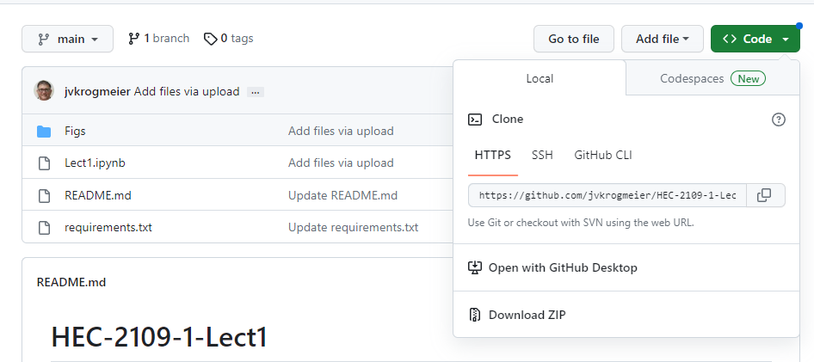

1. Unzip that file by extracting to this same folder using 7-Zip.

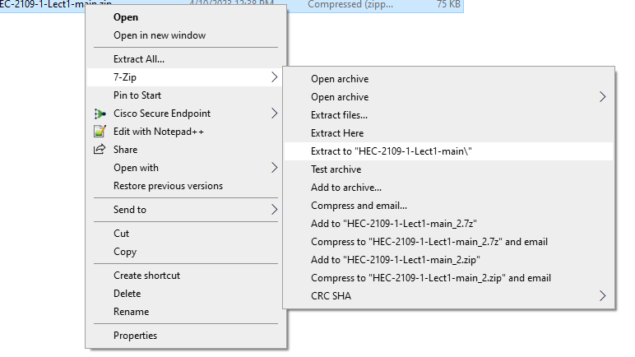

1. You will have 2 Lab folders and 4 lecture folders by the end of this class module.

VS Code user installation for local machine:

**Step 1:** To get started, you'll need to download the installer for Visual Studio Code. You can download it from the official website: <https://code.visualstudio.com/download>.

Once you're on the download page, you should see a button that says, "User Installer”. Select the x64 version for your computers. If you want to know more about the difference between the user and system installer you could visit the [VS Code page](https://code.visualstudio.com/docs/setup/windows#:~:text=VS%20Code%20provides%20both%20Windows,a%20smoother%20background%20update%20experience.) .

**Step 2:** **Saving in the correct folder on each computer is important.** Save in your folder which has your name.

1. Navigate to your REEU_”yourname” folder in the admin folder *username*(\\pasture.ecn .purdue.edu). You must have created this before downloading the REEU repo from Professor Krogmeier’s GitHub profile.
2. Save (or move) the “VSCodeUserSetup-x64-1.77.1.exe” file in this location. If it does not ask you for the location. Wait till it is downloaded then cut + paste (ctrl + X and ctrl +V) it to your folder.

**Step 3:** Run the installer file by double clicking on it.

1. Accept terms. Next
2. Next.
3. Next.
4. Next.
5. Install.
6. Finish.

It is now installed in your folder. You are the admin of the folder. So, it will not need any password anymore. Cancel any prompt that asks you for password.

**Step 4:** Search for VS Code in your search bar at the bottom of your screen. You should be able to see this screen for VS Code.

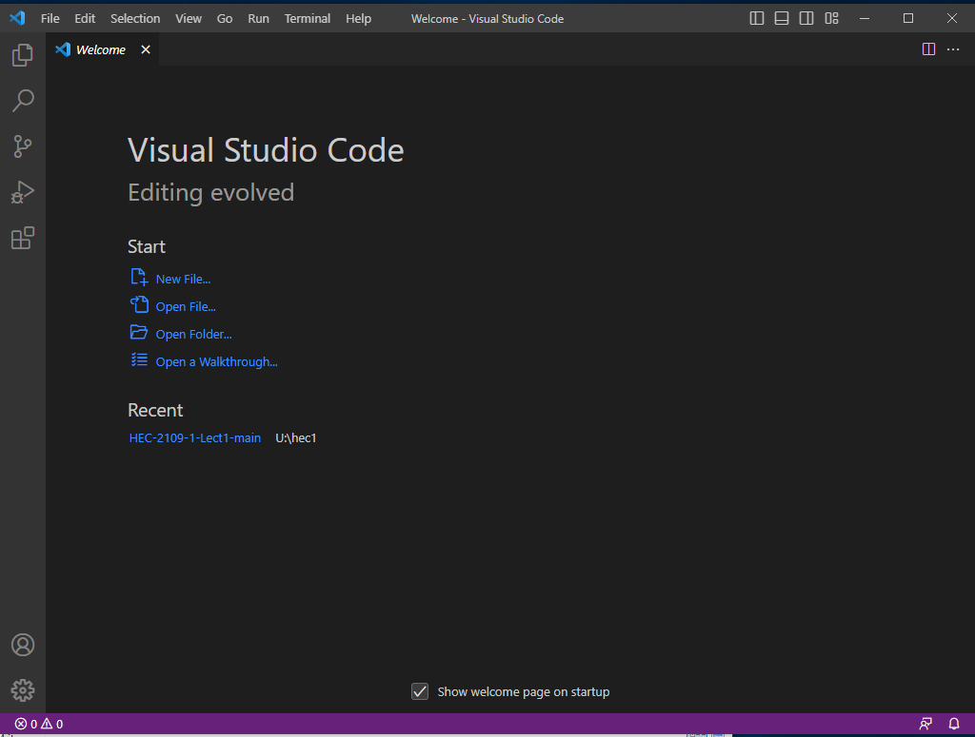

**Step5:** Select Open Folder... and navigate to the REEUPython folder (where you downloaded and unzipped the REEU GitHub repo) and open the REEUPython folder . Click on “open” to open the folder in the VS Code editor.

The VS Code editor should look like this.

**Step 6:** Install Python interpreter when prompted by VS Code. It will show up in the bottom right of the window. It will install the newest version of python to your VS Code. Be patient. This takes a minute.

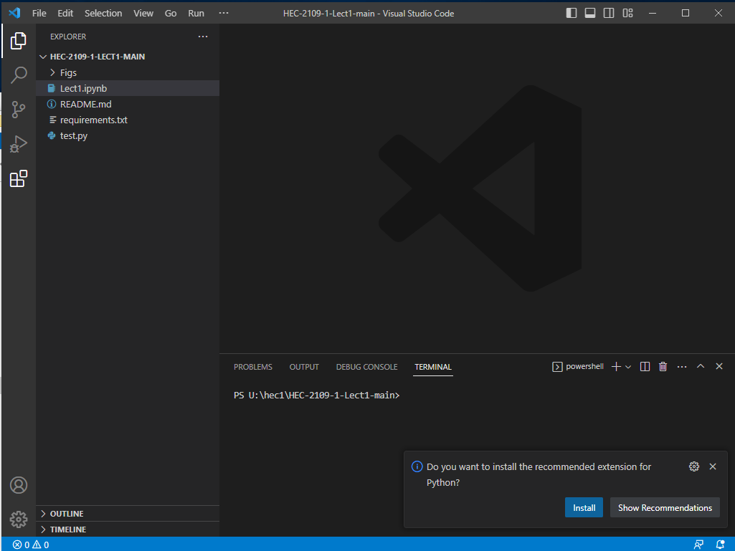

**Step 7**: If this Alert pops up, **Cancel** it. You do not need this.

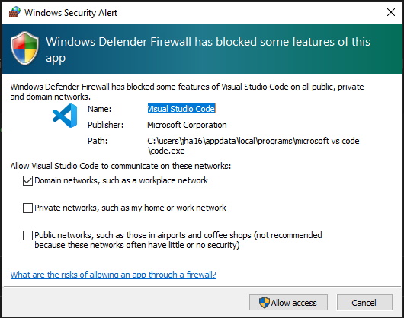

**Step 8**: Select your python Interpreter. It’s best to select the recommended one.

**Step 9**: Install the IPython kerned when prompted by IDE. This will enable the python interactive window. <https://code.visualstudio.com/docs/python/jupyter-support-py>

**Step10**: We will be working with Pandas, numPy and Matplotlib python packages for the first in the Lecture. As we are using python3 we should use pip3 to install the packages in the VS Code terminal. We will show package installation steps in the class. Meanwhile please read [this](https://code.visualstudio.com/docs/python/python-tutorial#_install-and-use-packages:~:text=Code%20debugging%20article.-,Install%20and%20use%20packages,-Let%27s%20build%20upon) and try it for yourself if you like.

**NOTE**: We will not be using python environments in these labs but it is good practice to create virtual environments for different python projects. To learn more about why? and how? you can read the “[Using Python environments in VS Code](https://code.visualstudio.com/docs/python/environments)” on VS Code’s official website.

**Step11:** Committing one-time changes to GitHub: [https://github.blog/2016-02-18-upload-files-to-your-repositories/](https://github.blog/2016-02-18-upload-files-to-your-repositories/%20) . We will discuss this in class too. Please remember GitHub is different from Git and this process is not version control. This will only help you publish your work on GitHub.